CHRISTMAS GREETINGS CAMPAIGN 2019-20
For this campaign we suggest that you write a simple card or greeting to the individual saying, for instance, that you are thinking of him/her and/or perhaps urging them not to lose hope (or words to that effect). A picture postcard is always welcome and cheapest to send. You can include your name and address (if you wish) but do not mention ACAT or include a religious motif or greeting (even a Christmas tree!) if so advised as communication from a foreign organisation can endanger the prisoner and lead to harsher sentences. Several individuals featured in previous campaigns have been released. Sadly others are still in prison and it is important not to forget them. As usual we include a selection of human rights groups. For individual prisoners or their families it is heartening to receive fairly regular cards of encouragement. Individuals who have already featured in ACAT appeals or campaigns are marked with an asterisk (*). Changes in their status, where known, are included in the information provided.
Members should not feel obliged to respond to every appeal case or to write to every address given for a case. Postage overseas is expensive: a letter or card (e.g. postcard) weighing up to and including 10g costs £1.35 to Europe and the rest of the world; a letter or card (e.g. a folded greetings card) up to 20g costs £1.35 for Europe (including the Ukraine and Russia) and £1.55 for the rest of the world. These are the rates as from March 2019 and at the time of printing.

GROUPS
You should sign your name to your message and by all means provide your address too, but be aware that UK groups may use this to invite you to join or donate to them. You may mention ACAT unless otherwise stated.
The INNOCENCE PROJECT, founded in 1992 in a law school in New York City exonerates the wrongly convicted in the USA through DNA testing and reforms the criminal justice system to prevent future injustice. To date, 367 people in the US have been exonerated by DNA testing, including 21 who served time on death row. The project works with congress, state legislatures and local leaders to pass laws and policies that prevent wrongful convictions and make it easier for the innocent to receive justice. It also assists exonerees in rebuilding their lives after many decades of incarceration. Help ranges from locating birth certificates and social security numbers to finding family members, securing housing or arranging for critical medical and psychological treatment. These people have served an average of 14 years in prison before exoneration and release.
The Innocence Project
40 Worth Street, Suite 701
New York, NY 10013
USA
Email: info@innocenceproject.org / press@innocenceproject.org


TALITHA KUM is a worldwide network of the religious and consecrated, founded in 2009 to promote initiatives against trafficking in people. Talitha Kum is an Aramaic expression taken from the Gospel of Mark (5, 41) meaning 'Young girl, I say to you, arise.' Jesus addresses these words to the 12-year-old daughter of Jairus, who lay apparently lifeless. Jesus then takes her by the hand and she immediately gets up and walks. In 2018 Talitha Kum networks helped 15, 500 persons who survived trafficking. Around three quarters of those were women and girls.

Talitha Kum
Piazza di Ponte Sant'Angelo, 28
00186 Rome, Italy
Email: coordinator@talithakum.info

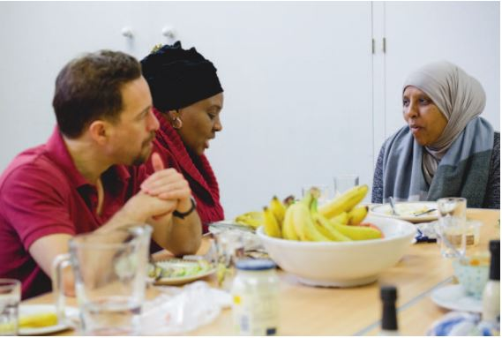
The JESUIT REFUGEE SERVICE (JRS) accompanies refugees and forced migrants in the UK, advocating their cause and focussing on those who are detained under the immigration rules or who are left destitute in the UK. Visiting the JRS in July 2018 and after listening to the stories of those accompanied by the JRS, who are struggling to gain recognition of their refugee status, Cardinal Vincent Nichols said, 'If you're here for 10 years and you can't have a residence, you can't study, you can't work, you have no income, it's as if you are being told you are a 'nonperson', and it's that darkness that we have listened to this afternoon. I can think of no other word than to say it is a shame on our country.' The JRS also calls for an end to the wrongful detention of asylum-seekers and of victims of trafficking or slavery. Every Thursday in their London Day Centre the JRS welcomes destitute refugees into a warm environment, offering food, company and advice and practical support.
Please send a message or greetings card expressing support to:

Jesuit Refugee Service UK
The Hurtado Jesuit Centre
2 Chandler Street, London E1W 2QT
Tel: 020 7488 7310
Email: uk@jrs.net
Website: https://www.jrsuk.net


REPRIEVE was founded in 1999 by British human rights lawyer Clive Stafford Smith to provide free legal and investigative support to some of the world's most vulnerable people: those facing execution, and those victimised by states' abusive counter-terror policies, including rendition, torture, extrajudicial imprisonment and extrajudicial killing. Based in London it is currently working on behalf of over 100 people facing the death penalty in 17 countries, and seven men imprisoned in Guantánamo Bay. It also campaigns against U.S.-led missile drone strikes in Pakistan and Yemen and for a world free of execution, torture and detention without due process.

Reprieve
PO Box 72054
London EC3P 3BZ
Tel: 020 7553 8140
Email: info@reprieve.org.uk
Website: https://reprieve.org.uk/

INDIVIDUALS
Please send a message to Pastor Zafar Bhatti, Pakistan
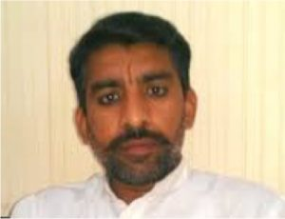
Pastor Zafar Bhatti has been in Rawalpindi's Adiala Central Jail since July 2012. Arrested for sending blasphemous text messages on a mobile phone (which was not registered to him), he was sentenced to life imprisonment in 2017 for blasphemy — a charge he denies. Before his arrest he founded a small NGO called Jesus World Mission to help the poor but in 2012 was accused by a local Islamic leader for sending text messages insulting the mother of Mohammed. Held in detention for almost five years before appearing before a court, he was tortured to extract a confession. Although an appeal court found that there was no evidence against him and he should be released, the prosecution and police have called for more time to produce evidence. Seven adjournments later over seven years, he remains in prison and has experienced several attempts to kill him. Still under threat, he now suffers from heart problems and diabetes and is not allowed to leave his cell. The Adiali Central jail is a favourite destination for political prisoners and dissenters arrested by the military and is notorious for its dreadful conditions. According to Release International his wife, Nawab, struggles to make ends meet and has sent her children to relatives. The family receive some support from Release.

Send a card (non-religious) but do not mention ACAT.
Zafar Bhatti
Central Jail
Adyala Rd
Rawalpindi
Punjab, Pakistan

Please send a message to Naser Navard Gol-Tapeh, Iran*
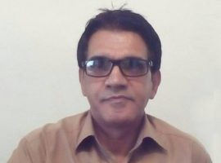
Naser Navard Gol-Tapeh* was arrested on 24 June 2016 at an engagement party at a house in Karaj, near Tehran. Everyone present was detained, including three visiting Azeri Christians from Baku, Azerbaijan. Most of the Christians were released after questioning and collection of their personal information, but Naser and the Azeris were transferred to Evin prison. Held in solitary confinement for two months and subjected to intense interrogation, they were all charged with 'illegal gathering, collusion and evangelism'. The Azeris were later allowed to leave Iran in November 2016, forfeiting their bail. At his trial in 2017 Naser was charged with 'acting against national security through the formation and establishment of an illegal church organisation in his home' and was sentenced to ten years in prison. In November he lost his appeal in spite of his lawyer providing numerous grounds for his innocence. In January 2018 he was moved to Evin Prison. He developed a severe gum infection for which he was denied treatment but in January 2019 was reported to be in good spirits and enjoying the company of other Christians. [* Last featured in our Christmas Appeal 2018.]

Send a card (non-religious), with your name and address if you wish, but do not mention ACAT.
Naser Navard Gol-Tapeh
Evin Prison
Tehran Province
Tehran
District 2
Islamic Republic of Iran
Please send a message to Saheb Fadaie, Yasser Mossayebzadeh, Mohammadreza Omidi and Pastor Youcef Nadarkhani, Iran

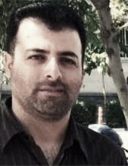
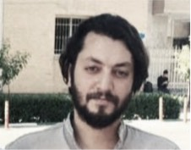
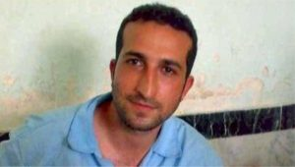
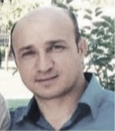
Saheb Fadaie [left] is a member of the Church of Iran house church network in Rasht, capital of Gilan province. In July 2018 he, Pastor Youcef Nadarkhani [right] and fellow church members Yasser Mossayebzadeh [bottom left] and Mohammadreza Omidi [bottom right] began ten-year prison sentence for 'acting against national security', 'propagating house churches', and 'promoting Zionist Christianity'. In September 2018 Saheb received another sentence (18 months) for 'spreading propaganda against the regime' following a house church meeting in the home of Fatemeh Bakhteri, who was sentenced to 12 months in prison, beginning 31 August 2019. All are in Evin prison. In September 2016 Saheb, Yasser and Mohammadreza were sentenced to 80 lashes each for the consumption of alcohol (communion wine). Non-Muslims are permitted to drink alcohol in Iran but since leaving Islam is forbidden converts to Christianity are not recognised as non-Muslims and thus may not drink alcohol. The outcome of an appeal against this punishment is awaited. In October 2019 Youcef went on a three-week hunger strike, which had a detrimental effect on his health. The prison authorities undertook to look into it. [Church in chains]

Send a message (non-religious) to each of the individuals if you wish, but do not mention ACAT.

[Name of Prisoner]
Evin Prison
Tehran Province
Tehran
District 2
Islamic Republic of Iran


Please send a message to Charles Flores, USA
Charles Don Flores, a Hispanic labourer, was sentenced to death in 1999 for the murder of 64-year-old Elizabeth Black during a home burglary in a Dallas suburb and has been on death row ever since. The conviction was heavily based on the testimony of a witness who underwent 'forensic hypnosis' that has been shown to be deeply flawed. The technique of hypnosis for such purposes has been scientifically demonstrated as false, giving the subject an inflated confidence in her ability to recall an event that had, most likely, never been encoded in her memory in the first place. Court-appointed defence lawyers failed to present any witnesses on his behalf.

Send a message (religious or non-religious). You can mention ACAT.

Charles Don Flores
#999299
Polunsky Unit
3872 FM350 South
Livingston, TX 77351 USA
Please send a message to Mancho Bibixy, Cameroon

Arrested without warrant by soldiers and after over 14 postponements of hearings, radio journalist Mancho Bibixy was sentenced in May 2018 by a military court to 15 years in prison and a huge fine (c. 409, 000 euros) for 'acts of terrorism, secession, propagation of false information, revolution, insurrection, contempt of public bodies and officials and hostility against the fatherland'. In poor health owing to bad and overcrowded prison conditions, he can communicate with his family only with the authorization of the Prosecutor and by paying fees. When he was arrested he was considered a leader of a peaceful demonstration against the marginalization of the English-speaking minority. The authorities' response in the conflict has been very violent, including the use of live ammunition against protesters, mass arrests, torture, humiliation and intimidation.
In late July reports emerged that Bibixy and other Anglophone detainees had been extracted from the Kondengui Central prison and tortured to death following violent protests. The Network for the Defence of Human Rights in Central Africa has dismissed the reports saying that he and the other detainees were still alive but had been severely tortured.

Send a message (religious or non-religious). You can mention ACAT.

Mr Mancho Bibixy
Yaoundé Central Prison
1000 Yaoundé
Cameroon
Please send a message to Nasrin Sotoudeh, Iran
Nasrin Sotoudeh, a prominent human rights lawyer in Iran, has been sentenced to a prison term totalling 38 years and 148 lashes for defending women's rights — the harshest sentence recorded against a human rights defender in Iran in recent years. A lawyer, she has a husband and two children. Nasrin Sotoudeh was arrested at her home on 13 June 2018 and later informed that she had been convicted on seven charges and sentenced to 33 years in prison and 148 lashes. The charges include 'inciting corruption and prostitution', 'openly committing a sinful act by... appearing in public without a hijab' and 'disrupting public order'. Although there is some confusion over the judge's ruling and its actual implementation, it appears that he applied the maximum statutory sentence for each of her seven charges and then added another four years to her total prison term, raising it from the statutory maximum of 29 to 38 years.

Send a message (non-religious) but do not mention ACAT.

Evin Prison
Tehran Province
Tehran
District 2
Islamic Republic of Iran

Please send a greeting on behalf of Leah Sharibu, Nigeria.

Leah Sharibu (16) is one of a group of 110 girls abducted by a Boko Haram faction in February 2018 from their school in Dapchi, Yobe state, in northeast Nigeria. The other girls are Muslims and were released in March, but Leah is a Christian and the militants said they would only release her if she converted to Islam. She refused. Leah is just one of thousands of women and children taken prisoner by Boko Haram since 2009. In August the Nigerian government released a statement confirming that Leah is still alive and that it is negotiating her release. In March, the militants released 104 of the girls but reportedly warned parents of the released girls not to send their daughters back to school (Boko Haram means 'western education is forbidden'). It is also reported that the releases followed an agreement that saw Nigerian armed forces withdraw from Dapchi, allowing the terrorists unhindered access. In September 2018 Boko Haram militants threatened to kill Leah and two other hostages if the Nigerian government did not pay ransoms. They eventually murdered two Red Cross midwives, considering them apostates because they worked for the Red Cross.
Leah, her father Natha and mother Rebecca are members of the Evangelical Church Winning All denomination in the state of Yobe, Nigeria.

Please send a message of encouragement to Leah's parents to strengthen them in their faith as they pray for the safe return of their daughter. You can send a religious card and mention ACAT.

Email: writetodapchi@opendoorsuk.org
No postal address is available.
Please send a greeting to Emil Ostrovko, Belarus.

In April 2018, waiting at a bus stop, 17-year old Emil Ostrovko (Emil Astrauko in Belarusian) was beaten by police officers, arrested and convicted for distributing illicit drugs. While working after school as a courier for an online company, his employer had told him the parcels he was delivering contained legal smoking mixtures. After months of detention he received a ten-year prison sentence for drug trafficking, later reduced to eight. Investigators never looked for the owner of the company, nor anyone else. Some 15,000 people are serving lengthy prison sentences in Belarus for petty drugs offences. They are treated far worse than other offenders and forced to do long hours of hard labour. Emil was not allowed to carry his asthma medicine and got frostbite from clearing snow with his bare hands. Things improved a little when he went to an adult prison.

Send a (religious or non-religious) greeting and message of encouragement. You can mention ACAT.
Emil Vadimovich Ostrovko
Correctional Colony Number 2
Ul. Sikorskogo 1, otryad 1
Bobruisk
Mogilevskaya oblast
213800
Belarus

Please send a (non-religious) message to the family of Ibrahim Ezz El-Din, Egypt.
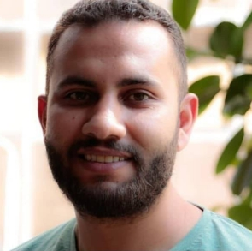
Ibrahim Ezz El-Din is a 26-year old architectural planning engineer and researcher at the Egyptian Commission for Rights and Freedoms (ECRF) who worked on the right to affordable housing and reported on forced evictions in Egypt. ECRF’s staff members have been subject to continuous harassment by the authorities for reporting on abuses and crimes committed by the Egyptian authorities and for campaigning against enforced disappearances. On 11 June 2019, while walking home, Ibrahim was surrounded and arrested by security officers and taken to an unknown location. The local police station told his mother that he was not there, denying that he was detained at all. Ibrahim is the fifth person linked with the ECRF to have been arrested in just three years. Hundreds of people like him have been forcibly disappeared and held in prison for months without ever being brought to trial. Many have been arrested simply for expressing their opinions peacefully or criticizing the authorities.

Send a (non-religious) message to the family of Ibrahim. Do not mention ACAT.
The Family of Ibrahim Ezz El-Din
C/o The Egyptian Commission for Rights and Freedoms
4A, Al-Saraya al kobra,
Garden City
Cairo, Egypt

REMEMBER IN YOUR PRAYERS
Esraa Abdel Fattah, a journalist and campaigner for women's rights in Egypt, who was abducted, ill-treated, tortured and detained.

Ahmed Mansoor, a human rights activist, who has been sentenced to ten years in prison in the United Arab Emirates, where he has spent long periods in solitary confinement and is in poor health.

Galal El-Behairy, an Egyptian poet and activist who has been in detention in Tora Prison in Cairo since March 2018 for speaking out against political and economic corruption.

Mancho Bibixy, a journalist and broadcaster who has been sentenced to 15 years in prison in Cameroon for taking part in demonstrations defending the rights of Anglophones. He has reportedly been tortured.

Pray also for: Leah Sharibu, a Christian girl who was abducted by Boko Haram in Nigeria; Nasrin Sotoudeh, a human rights lawyer and defender of women's rights who has been sentenced in Iran to 38 years in prison and flogging; Charles Flores, who has been on death row in Texas, USA, for 20 years after being convicted on dubious evidence; Saheb Fadaie, Yasser Mossayebzadeh, Mohammadreza Omidi, Pastor Youcef Nadarkhani, Naser Navard Gol-Tapeh and Ebrahim Firouz, Christian prisoners in Iran; Pastor Zafar Bhatti, a Christian prisoner in Pakistan; Emil Ostrovko, a juvenile sentenced to eight years in prison in Belarus; and Ibrahim Ezz El-Din, a human rights worker in Egypt who has been abducted and whose whereabouts are unknown.

