CHRISTMAS GREETINGS CAMPAIGN
For this campaign we suggest that you write a simple card or greeting to the individual saying, for instance, that you are thinking of him/her and/or perhaps urging them not to lose hope (or words to that effect). A picture postcard is always welcome and cheapest to send. You can include your name and address if you wish but do not mention ACAT or include a religious greeting or motif (even a Christmas tree!) if so advised, since communication from a foreign organisation can endanger the prisoner. Several individuals featured in previous campaigns have been released. Sadly others are still in prison and it is important not to forget them. Changes in their circumstances are described, where known. As usual we include a couple of human rights groups. For individual prisoners or their families it is heartening to receive fairly regular cards of encouragement. Do not feel obliged to respond to every appeal case or to write to every address given for a case (we present several in some cases). Postage overseas is expensive: a letter or card (e.g. postcard) weighing up to and including 20g currently costs £1.70 to Europe and the rest of the world.
https://www.royalmail.com/sites/royalmail.com/files/2021-03/royal-mail-our-prices-april-2021.pdf

GROUPS
René Cassin works to protect and promote the rights of vulnerable individuals and communities, particularly on issues that resonate with the Jewish experience. Her registered charity is currently working on mass detention, forced labour, forced sterilisation, destruction of religious sites, and near-total digital surveillance in China. Other areas include women's rights, slavery and trafficking and tackling hate crime. The charity is also campaigning for an end to the indefinite detention of asylum-seekers.

Please send a greeting to:
René Cassin
853 Finchley Road
London NW11 8LX
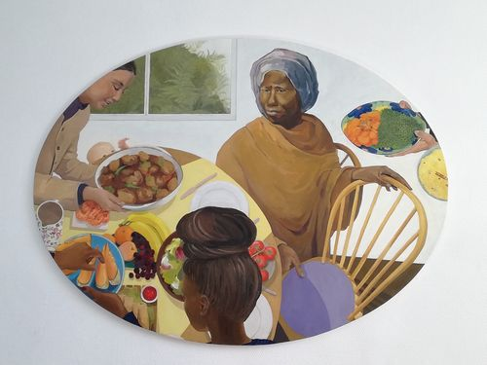
CARITAS BAKHITA HOUSE in Westminster, London, is a centre for the emergency placement of women escaping from trafficking and its physical and emotional abuses. It assists the most vulnerable and traumatised individuals, both from the London area and elsewhere in the UK, by providing accommodation, medical help, legal/financial assistance and mentoring. The house is owned by the (RC) Diocese of Westminster and managed by Caritas Westminster. Its partners include the Metropolitan Police Anti-Trafficking Unit, local parishes, and the Adoratrices Sisters, whose work includes liberating women affected by prostitution and trafficking. Since opening in 2015 the house has welcomed 123 guests (ranging from 15-70 years in age) and 11 babies, hailing from 39 different countries, all of whom are provided with the support necessary to build a new future. In the words of one guest:

‘I worked continuously, seeing many clients a night, until one night both my body and my mind felt completely broken. A police officer stopped and spoke to me; it was the first kindness I had been shown in a long time. Within an hour of being taken off the streets, the police took me to Bakhita House and I entered a different world. For the first time in ten years, I slept all night undisturbed. For the first time, I felt safe.’

The house is named after Josephine Bakhita (1869-1947) who was born in Sudan, kidnapped by Arab slave traders at the age of seven and repeatedly bought and sold. She was so traumatised by her captors' brutality that she could not remember her own name and was mockingly dubbed 'Bakhita' — the fortunate one. With 144 permanent scars on her body by the age of 13, her final owner brought her to Italy, where she was cared for by nuns and released from slavery. Baptised in 1890 and taking the name Josephine, she became a Canossian Sister and was the first Sudanese national to be canonised as a saint. [Picture: St Josephine Bakhita, imagined at Bakhita House, by Mabel Symons]

Please send a message or greetings card expressing support to:
Ms Finola Ryan
Caritas Development Team
Vaughan House
46 Francis Street
London SW1P 1QN
Email: growinginfaith@rcdow.org.uk
Tel: 020 7798 9099

INDIVIDUALS
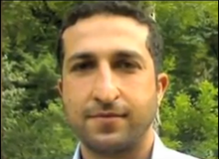
Yousef Nadarkhani (pictured) and three of his church members, Saheb (Zaman) Fadaee, Mohammad Ali (Yasser) Mosayebzadeh and Mohammad Reza Omidi, were sentenced in 2018 to ten-year prison sentences on charges of “acting against national security” and also of “promoting Zionist Christianity.” The men, who were first featured in our Easter greetings campaign in 2019, are all members of the Church of Iran. Omidi was released into two years internal exile in August 2020. Yasser's sentence was reduced to three years in January 2021 and he was released from prison in February 2021 on condition of having no interaction with other Christians or engaging in Christian activities.
A Christian since the age of 19, Yousef had already spent nearly three years in prison after being sentenced to death for apostasy in 2010, but was acquitted in September 2012. A second arrest followed in 2016 and he was sentenced in 2017/18. Yousef is known to have been beaten in detention. In June 2020 his sentence was reduced to six years. His wife is also a convert and the couple have been fighting for over ten years for their two boys to be recognized as Christians. For the past several years the boys have been denied certificates showing they completed their studies because they refused to take Islamic classes. [Picture: Wikipedia]

After Muslims Christians are the second largest religious denomination in Iran, although they probably represent around one percent of the population. Although Armenian and Assyrian Christians are recognised and protected by the state, they are treated as second-class citizens and are not permitted to discuss the figure of Jesus with other people or to speak in Persian during their church services. On the other hand members of illegal Protestant 'house churches' — groups of up to around 12 members each — such as the Church of Iran pay a heavy price if discovered and are often accused of collusion with and accepting support from enemy countries, especially Israel and the West. Converts are particularly targeted. Nevertheless house churches are reported to exist all over Iran, especially in the cities, and are claimed by evangelical groups to be growing.

In February 2019 nine more members of the Church of Iran were also arrested in Rasht. Helping to lead the church in Pastor Nadarkhani’s absence, they were all given five-year prison sentences. Neither they nor their lawyers were allowed to attend an appeal hearing in February 2020. Their names are:

Babk Hosseinzadeh,
Mehdi Khatibi,
Kamal Naamanian,
Mohammed Vafadar,
Behnam Akhlaghi,
Khalil Dehkanpour,
Hossein (Elisha) Kadivar,
Shahrooz Eslamdous,
Abdolreza (Matthias) Haghnejad.

Abdolreza (Matthias) Haghnejad has reportedly been moved to a prison in Bandar Anzali, for which no address is currently available. The others are in Evin Prison, Tehran.
You may wish to send a non-religious card/greeting to one or more of the above prisoners, giving them encouragement and reminding them that they are not forgotten. Do not mention ACAT.
Prisoner's name
Evin Prison
Saadat Abad
Tehran
Islamic Republic of Iran

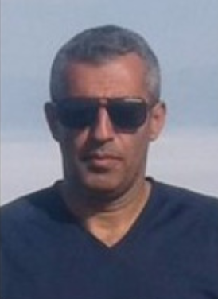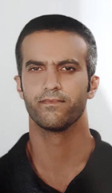

Left to right: Babk Hosseinzadeh, Kamal Naamanian, Shahrooz Eslamdous [Pictures: https://articleeighteen.com, https://prisonersoffaith.vom.org]


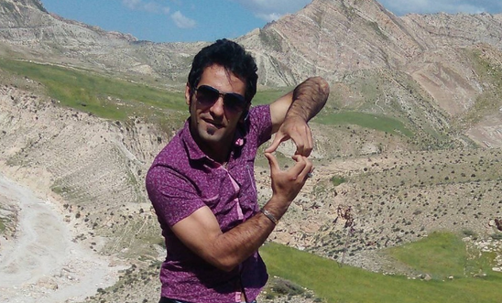
In November 2019 Hadi Rostami, a Kurdish Iranian, was sentenced to having four of his fingers amputated following a grossly unfair trial in which confessions obtained under torture were used to convict him of robbery. In late 2020 he was further sentenced to 60 lashes and eight months imprisonment for 'disrupting prison order', a sentence which was carried out on 14 February 2021 while he was suffering from physical injuries to his digestive system caused by trying twice to commit suicide after swallowing broken glass. At the time of writing the amputation sentence had not been carried out. By drawing media attention to Iran's policy of amputation Hadi appears to have irritated the authorities, who have threatened to perform the amputations immediately. On 8 December 2020 Hadi wrote to Ali Akbar Garousi, Chief Justice of West Azerbaijan province, saying he had been tortured during his detention by intelligence agents and that he and his two co-defendants had been unjustly sentenced based on their confessions under torture. He demanded re-examination of the case and revocation of the amputation order. He has also been beaten and denied proper medical treatment and mental health care. The Iranian Penal Code incorporates amputation as a punishment for a certain type of theft (sariqa). See our main article above for background.
Hadi Rostami was internally exiled to Tabriz Prison from Urumieh (aka Orumiyeh or Urmia) Central Prison in West Azerbaijan Province on 19 December 2020, without prior notice. However, Tabriz prison officials refused to accept him and he was returned to Urumieh after one day, where he was flogged around 13/14 February 2021. On 18 February he was transferred to Bukan Prison, where conditions are reportedly bad (according to the Iran Prison Atlas) and where he is still believed to be. There is no publicly available address for Bukan Prison but the following is the closest we can provide:

Bukan Prison
West Azerbaijan Province
Islamic Republic of Iran

Apart from Hadi Rostami there are reportedly five other prisoners convicted of theft following confessions extracted through torture and sentenced to the 'amputation of four fingers of a hand'. They are:

37-year-old Mehdi Sharafian,
42-year-old Mehdi Shahivand,
35-year-old Shahab Teymouri,
39-year-old Mehrdad Teymouri,
and 40-year-old Kasra Karami.

Please send a non-religious greeting (do not mention ACAT) to one or more of them at:
Urumieh Central Prison
West Azerbaijan Province
Islamic Republic of Iran



Freelance journalist Zhang Zhan, a well-known activist for human rights in China, was detained in May 2020 as a reprisal for her coverage of the Covid-19 pandemic from February 2020. She reported on the detention of other independent journalists in Wuhan and the harassment of families of victims seeking accountability. Her licence to practise as a lawyer has been revoked. During July and August 2021 she was hospitalised due to her deteriorating health as a result of an ongoing hunger strike begun in June 2020. Tied to a bed and force-fed, Zhang Zhan is in extremely poor health, suffering weight loss, severe malnutrition, a gastric ulcer, and swollen legs and feet. She was later transferred back to the Shanghai Women’s Prison, where she is currently believed to be held.
Zhang Zhan’s family have no direct physical contact with her, although they have twice communicated by phone. After seven months of pre-trial detention, on 28 December 2020, the Shanghai Pudong People’s Court found Zhang Zhan guilty of 'picking quarrels and provoking trouble' (Article 293 of China’s Criminal Law) and sentenced her to four years in prison. The court rejected an application filed by her lawyers for bail, and refused to allow live-streaming of the trial or a time extension for the proceedings. It also rejected requests for defence witnesses to appear in order to present exculpatory evidence. Zhang Zhan attended her trial in a wheelchair and was force-fed via a nasal tube during her detention. [Picture: South China Morning Post/YouTube]

Please send a non-religious greeting (do not mention ACAT) to:
Ms Zhang Zhan
Songjiang Women's Prison
No.1601, Zhang Jing Road
Sijing Town
Songjiang District
Shanghai, China

If you wish also to appeal to the authorities on her behalf , please write to the following (do not mention ACAT):
Xi Jinping
President of the People's Republic of China
Zhongnanhai
Xichangan’jie
Xichengqu, Beijing Shi 100017
People's Republic of China
Salutation: Dear President

Mr Li Keqiang
Prime Minister of the People’s Republic of China
Email: premier@mail.gov.cn
Salutation: Dear Prime Minister

Mr Guo Shengkun
Minister of Public Security of the People’s Republic of China
Email: gabzfwz@mps.gov.cn
Salutation: Dear Prime Minister

H.E. Mr Zhaoxu Ma H.E. Mr Zhaoxu Ma
Ambassador
Permanent Mission of the People’s Republic of China to the United Nations
11 Chemin de Surville
1213 Petit-Lancy
Geneva
Switzerland
Email：chinamission_gva@mfa.gov.cn / chinamissionspeaker@gmail.com
Twitter：https://twitter.com/Amb_ChenXu /
https://twitter.com/Amb_LiSong
https://twitter.com/ChinaMissionGva
Salutation: Your Excellency / Dear Ambassador

H.E. Zheng Zeguang
Embassy of the People's Republic of China
49-51 Portland Place
London W1B 1JL
Tel: 020 7299 4049, 0797 0292561 (24 hours)
Fax: 020 7636 2981/7636 5578
Email: political_uk@mfa.gov.cn
Salutation: Your Excellency / Dear Ambassador

Suggested message:
Salutation
I write on behalf of Ms Zhang Zhan, a journalist and former lawyer, who has been detained and convicted for reporting on the Covid 19 crisis as it broke out in Wuhan in February 2020. In December 2020 the Shanghai Pudong People’s Court found her guilty of 'picking quarrels and provoking trouble' (Article 293 of China’s Criminal Law) and sentenced her to four years in prison. At her trial the court refused her bail and also refused to hear defence witnesses with exculpatory evidence.
Ms Zhang Zhan is now in very poor health following a hunger strike. I would urge you to take steps to ensure her physical integrity and psychological health and to enable access to her family members and to a lawyer of her own or her family’s choosing. Since she has committed no recognisable criminal offence (or any that would be recognised in international law), I would also urge the Chinese judiciary to repeal the guilty verdict and release Zhang Zhan immediately and unconditionally: her current detention is arbitrary since its only aim seems to be to punish her for her legitimate human rights activities.
Yours respectfully



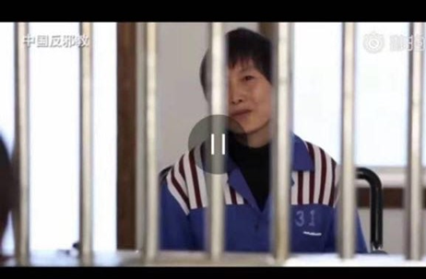
In 2017 sisters Ju Dianghong (pictured) and Liang Qin were sentenced to jail terms of 13 and 10 years respectively for their Christian activities. Christians in China’s southern Yunnan province face long prison sentences as Chinese authorities try to eradicate their religion under the guise of cracking down on 'evil cults'. In 2016 Yunnan officials formed an investigative team dedicated to wiping out the Three Grades of Servants religious sect, which China regards as a dangerous cult, and launched systematic attacks against them. The authorities conducted mass arrests of more than 200 Christians across the province. In 2018 around 40 were still in custody, facing long sentences. Their lawyers are under official review just for defending them. Ignoring their denials that they ever belonged to the cult, Chinese officials sentenced six of these imprisoned Christians — Ju Dianghong, 46, Liang Qin, 30, Zhang Hongyan, 34, Zi Huimei, 30, Yang Shunxiang, 29, and Zhang Shaocai, 42 — to between four and 13 years in prison. Ju Dianghong and Liang Qin claimed they were never involved with the sect and had never heard of it, but were accused of leading and recruiting members, doing missionary work and spreading news of the apocalypse on behalf of the cult. In its verdict the court stated that Christianity could fall under the definition of an 'evil cult', supported by the possession of Christian books such as 'Pilgrim’s Progress' and 'Streams in the Desert'. In fact the cult is deemed dangerous by mainstream Christians and probably died out after a crackdown in 2005-6, but it is used by the authorities as a catch-all to persecute other Christians. Christians face many perils in prison. The Chinese government infamously persecutes those it deems “enemies of the state,” many of whom are Christians. Christian prisoners often suffer torture, beatings, and even death at the hands of prison officials. Others leave their cells in extremely poor physical and mental health from subjection to inhumane practices and medical neglect. The location of their prisons — in remote areas over 1,000 miles from homes and families —is rarely disclosed and requires exhaustive research by Christian charities to uncover. This is also true of Ju Dianghong and Liang Qin. [Picture: ChinaAid]
Please send a non-religious card/greeting to the women at the following address, reminding them that they are not forgotten. Do not mention ACAT.
Liang Qin
No. 1 Prison for Women of Yunnan Province,
Kunyang Town, Jinning District,
Kunming City, Yunnan Province,
China 650600
Ju Dianghong
No. 1 Prison for Women of Yunnan Province,
Kunyang Town, Jinning District,
Kunming City, Yunnan Province,
China 650600



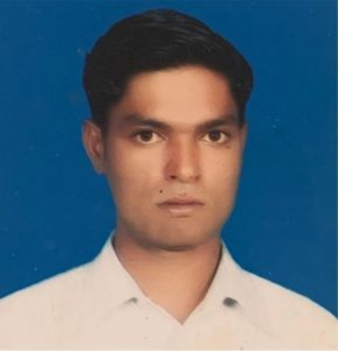
Ashfaq Masih (34) has been in prison in Pakistan since 2017, when he was accused of blasphemy. He is still awaiting trial as his court hearings have been cancelled repeatedly because the judge or witnesses failed to appear. A bicycle mechanic from the Christian Mariam Colony in Lahore, Ashfaq Masih was accused of blasphemy after he was involved in a dispute with a Muslim customer over payment for repairing a bicycle. It is not unusual in Pakistan for Christians to be targeted in this way over minor business disputes that escalate into religious disputes. The customer claimed to be a poor sadhu (holy man) demanding a rebate on the cost of the bicycle repair. A crowd gathered and Ashfaq was accused of blasphemy for reportedly insulting the Prophet Muhammad by telling the bicycle owner that Christians believe Jesus was the final prophet. Police were called and arrested Ashfaq, who is imprisoned in the District Jail (aka Camp Jail), Lahore. Ashfaq’s family is very poor but his older brother is hoping to start a small business.

Please send a non-religious greeting (do not mention ACAT) to:

Ashfaq Masih
District Jail Lahore
Ferozepur Road
Shadman 1 Shadman
Lahore
Punjab 54000
Pakistan



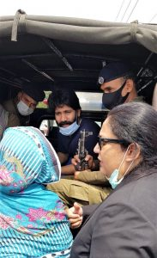
Salamat Mansha Masih and his friend Haroon Ayub Masih (both aged 26) were accused of blasphemy after a group of Muslims heard them reading the Bible in Lahore’s Model Town Park on 13 February 2021. Haroon fled the park but Salamat was arrested and spent over two months in detention before being presented before a judge on 16 April (24 hours is the required period). According to his lawyer, during this period he was kept in at least three different police stations and illegal torture cells. Police threatened to kill him, and his family were not allowed to see him before he appeared in court. The family were not allowed to talk to him until a week later.
The police investigators reportedly forced him to admit to blasphemy and tortured him into naming other members of his Bible study circle. Police registered a case for derogatory remarks against the Prophet Muhammad (Section 295-C of the Pakistan Penal Code, punishable by death); defiling the Quran (Section 295-B, punishable by life imprisonment and a fine); and deliberate and malicious acts intended to outrage religious feelings (Section 295-A, punishable by up to ten years in prison and a fine). [Picture: Daily Morning Star: Salamat Mansha Masih (centre), with mother (left) and lawyer (right) arriving at Lahore Prison on 23 April 2021]

Please send a non-religious greeting (do not mention ACAT) to:

Salamat Mansha Masih
District Jail Lahore
Ferozepur Road
Shadman 1 Shadman
Lahore
Punjab 54000
Pakistan



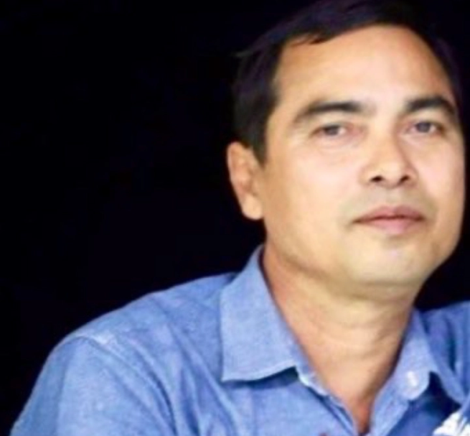
On 3 March 2021 journalist Min Nyo was arrested and severely beaten by police while he was covering a pro-democracy protest against the military coup in Pyay, Bago Region. On 12 May 2021 a military court in Pyay Prison found him guilty of attempting to 'hinder, disturb, damage the motivation, discipline, health and conduct' of soldiers and civil servants and 'cause their hatred, disobedience or disloyalty toward the military and the government' (Penal Code, Article 505-a) and sentenced him to three years in prison. He is currently detained at Pyay Prison, where he is at risk of being tortured, and is appealing against the verdict. Mr Min Nyo is also featured in our section for appeals to authorities. [Picture: DVB, cpj.org]

Please send a non-religious greeting (do not mention ACAT) to:
Min Nyo
Pyay Prison
R6HC+P8Q, Pyay
Bago Region
Myanmar
REMEMBER IN YOUR PRAYERS

Min Nyo, who was arrested and badly beaten by police in Myanmar for reporting on a pro-democracy protest against the military coup there. Also Khet Thi and Sein Win, poets critical of the regime, who were tortured and murdered.
Human rights lawyers Harika Günay Karataş and Tevfik Gündüz in Turkey, who were verbally and physically assaulted by an official.
Abdullah al Howaiti, arrested in Saudi Arabia aged 14, tortured into confessing to a killing he could not have committed, and facing the death penalty.
Chang Weiping, a human rights defence lawyer in China, detained incommunicado in January 2020 and again in April 2021, interrogated and tortured, and threatened with severe penalties for activities deemed subversive to the state.
Also the many victims of abuse, religious persecution and torture, including Yousef Nadarkhani, Babk Hosseinzadeh, Mehdi Khatibi, Kamal Naamanian, Mohammed Vafadar, Behnam Akhlaghi, Khalil Dehkanpour, Hossein (Elisha) Kadivar, Shahrooz Eslamdous, Abdolreza (Matthias) Haghnejad, Hadi Rostami, Mehdi Sharafian, Mehdi Shahivand, Shahab Teymouri, Mehrdad Teymouri, Kasra Karami (all Iran); Zhang Zhan, sisters Ju Dianghong and Liang Qin (China); Ashfaq Masih and Salamat Mansha Masih (Pakistan).

WORDS FOR THE MAGI
By Elizabeth Jennings

‘Shall I bring you wisdom, shall I bring you power?’
The first great stranger said to the child.
Then he noticed something he’d never felt before –
A wish in himself to be innocent and mild.

‘Shall I bring you glory, shall I bring you peace?’
The second great stranger said when he saw
The star shine down on entire helplessness.
The gift that he offered was his sense of awe.

‘Shall I show you riches’ the third one began
Then stopped in terror because he had seen
A God grown-up and a tired tempted man.
‘Suffering’s my gift’ he said
‘That is what I mean.’

ACAT-UK wishes all its members and supporters a Blessed Christmas and all the very best for the New Year.

